Texturing2—using projections and hypershade editor

1. start with existing material, lambert, open it up in attribute editor
2. choose checker icon next to color
3. in create render node window 🡪 right-click file > create as projection
4. in “file 1 window” open up tile image file from source images

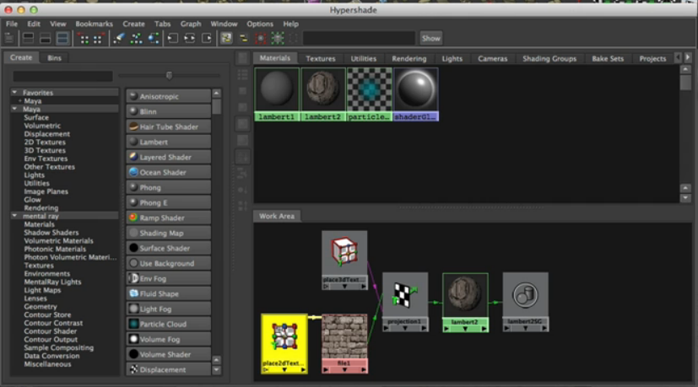

material node (lambert) has link to projection node that you just made

and, in turn, the projection node uses an image that’s projected onto the surface

and there are two placement controls: place2d-texture = placement node

and place3d-texture node

1. Select place3d-texture node (it should be in object list) and choose “fit to Group Bbox” – stretches single copy of file to surface
2. Selection “projection 1 node” to make ProjType: Tri-planar
3. Choose place3d-texture again. then choose SPECIAL manipulator tool and (looks like a light blue pyramid with the regular-looking manipular on top)
4. Then, click on the handles of the 3d-texture (little line coming off of diamond) to move the projection
5. make 3d-texture node as child of the geometry

BUMP MAPPING

1. selected the assigned material (lambert) in the hypershade menu, middle mouse click the projection1 and drag and drop to “Bump mapping” slot
2. select “bump3d1” from hypershade editor, and adjust bump depth

DISPLACEMENT MAPPING

1. open hypershade, select lambert, and press::Screen Shot 2013-05-10 at 1.11.20 PM.png button, to graph the shader
2. graph the shader too, by selecting it and pressing ::Screen Shot 2013-05-10 at 1.11.20 PM.png again
3. Middle mouse click and drag “proj 1” from hypershade into “Displacement Mat” window of “lambertSG1” shader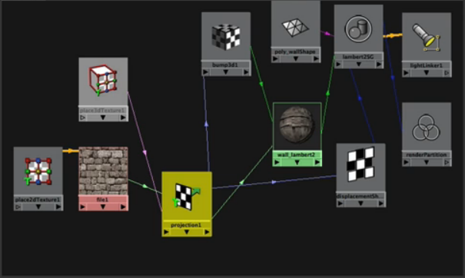
4. Select projection 1, open up roll-out for “Color Balance” and change the Alpha Gain from 1 to ~0.1 \* VIEW IN MENTAL RAY
5. You can also just create the displacement map in MUDBOX

BEVEL EDGES—to fix cracking in displacement map of projected texture

1. add bevel, right before you place file texture
2. To bevel: select geometry edges you want to bevel
3. Polygons module> edit mesh>bevel (options)

-try 3 segments

1. Before you convert to file texture, you can bevel
2. adjust influence by opening up projection 1 and adjusting the alpha gain

CONVERTING PROJECTION to FILE TEXTURE (for uv mapping/bringing in mudbox)

1. In hypershade editor, select the material Lambert and shift-select the geometry

YOU CAN BUILD AN ENTIRE STRUCTURE OF RECTANGULAR POLYGONS and then APPLY THE PROJECTION!!!!!!!!!!!

1. Edit (in hypershade window)>Convert to file texture (maya software) Options >  
   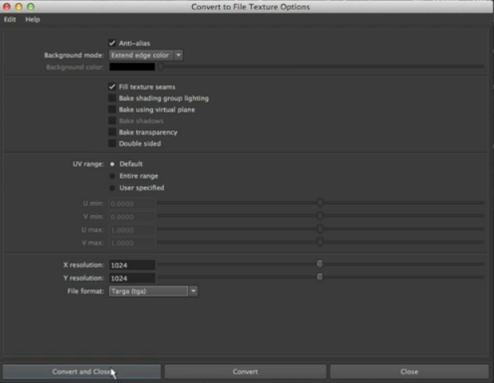

OR (instead of above method for file texturing):::::

1. From rendering module>lighting/shading> batch bake (mental ray)

TO MAKE A TILE MORE SEAMLESS

1. 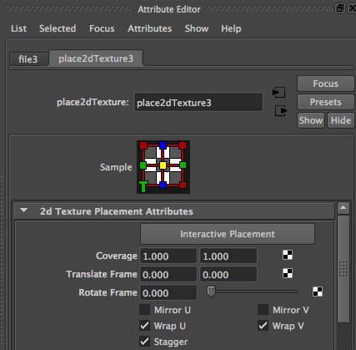
2. 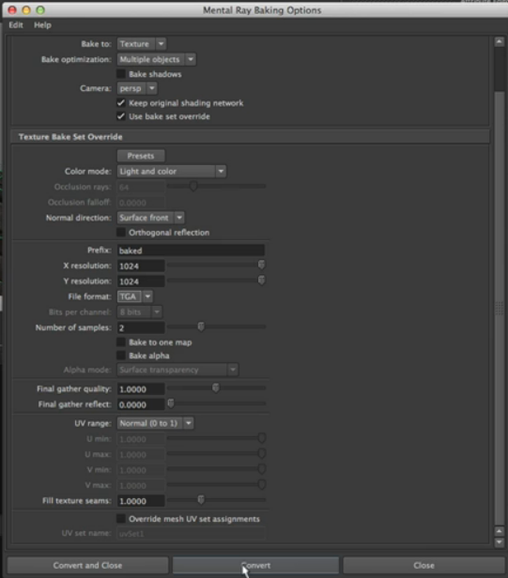

PHYSICAL SUN AND SKY

1. press rendering preferences::Screen Shot 2013-05-10 at 1.49.44 PM.png
2. 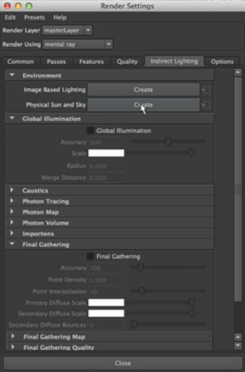
3. Slows down render alot